Clothing delivery system
Introduction
The clothing delivery system is an existing system I made for a customer to give clothing to other companies (employees). This system is made in asp.net and I want to create a new modern version with Angular / Nodejs and Mongodb. The system stores clothing stock for every company and makes orders and invoices.

List of Feature
- Company data
- Article data
- Stock
- Orders
- Invoices
- Company (customer) login
- Export to excel
- Inventory
- Transfer
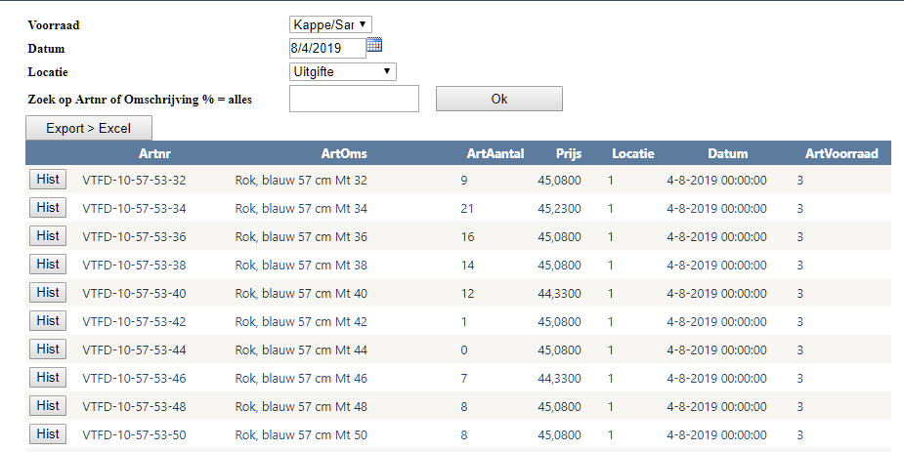
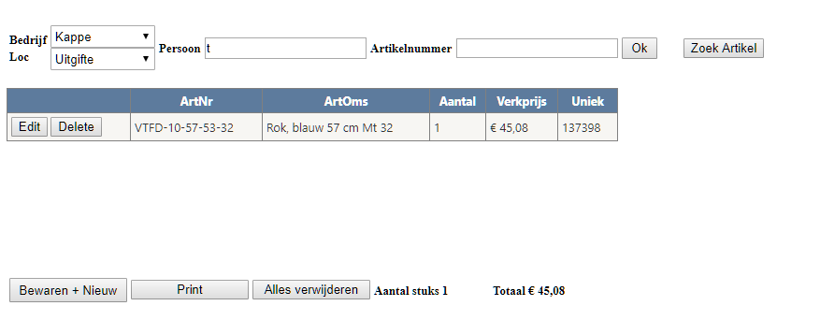

New features
Because it is build around 2007 I like to expand the system with new features like:
- Use app on mobile devices.
- Export invoices and orders directly to the cloud. (dropbox).
- Better security.
- Better performance.
- Nicer/modern look and feel.
- Don’t need the use of Microsoft IIS and MS Sql. (Want to host it on a Linux environment with Microsoft you need Microsoft server which is expensive and heavy for a simple application like this one).
Market Survey.
There are a lot of stock systems around (see examples) but this one is client specific. It needs more than one price for an article. Multi company. Company (customer) login to view the stock orders and invoices. It has to use the existing scanners for the 6 months inventory. It needs to be simple to use with a barcode scanner.

Examples of fashion erp:
- https://reflecta.nl/
- https://www.aims360.com/
- https://www.salesforce.com
- https://www.deskera.com
- Sap erp
- Microsoft Dynamics

References
The old system is the base for this project it was created / build around 2007 in asp.net. It needs to be updated to make it more stable / secure and future prove. And I like to use open source products like.
https://angular.io/
https://www.mongodb.com/
https://nodejs.org/en/

